# DESIGN OVERVIEW

Describe/show the overall design of the game. This is the elevator pitch on a single page, preferably with art.

* Our game is a pipe connecting puzzle game, helping the character poo to arrive to the goal.

Who is the target audience?

* Overall ages of audience

What will the rating be?

* E for everyone.

What are the bullet points that will sell the game?

* This game is with a cute poop character!
* Make a path for the poop to reach to its goal

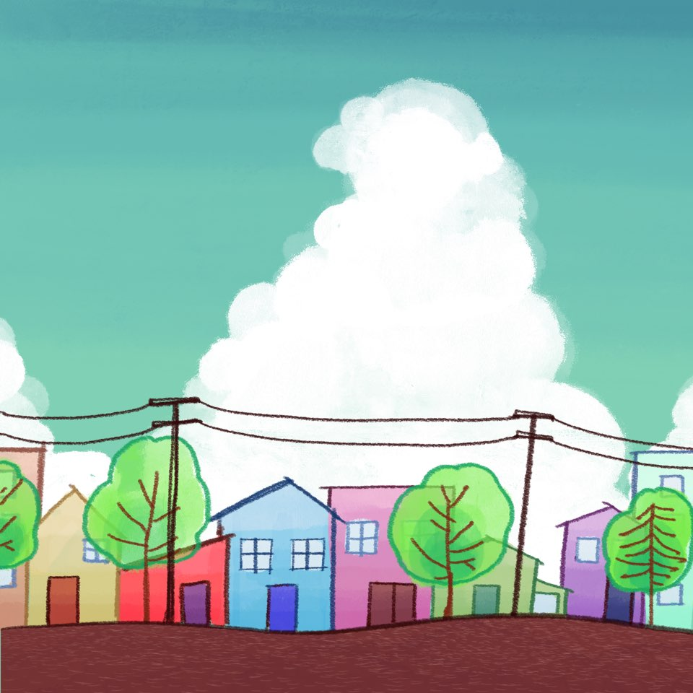

# COMPETITIVE RESEARCH

Show other games that are similar to yours and makes points about their relative strengths and weaknesses. Use screenshots.

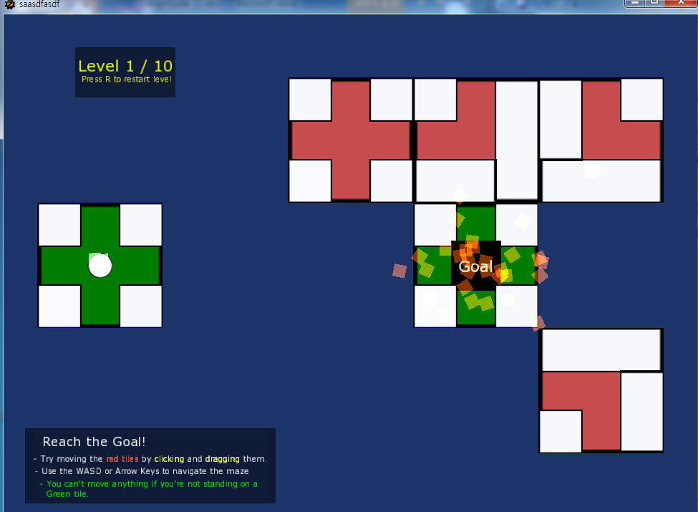

## Jigsaw Jam is a game which has a very similar design of our project. The starting point and end point are already set, then the players need to match the puzzle on the spaces so the ball could get through and reach to the goal.

## The benefits what we thought this game has is there are components which enhances the interest of the game which we don’t have. One of them is that the ball doesn’t automatically move when the puzzle is solved. However, the player could control the ball to move even the puzzle is yet unsolved. This movement of the ball affects the block changing them to moveable or not. For example, when the player placed block number 1 and the player controlled the ball to pass through the num.1 block to num.2, as the block got pass through, it is able to move block num 1 again. By using this structure of the game, it is able for the player to use various ways to solve the puzzle.

## The game has simple graphics and the blocks characteristics are distinguished by its color (the green is the goal or save point, and red is the blocks which is moveable, and the blue block is which is rotatable). They gave an additional particle effect which distinguishes the green blocks if it is just a save point or a goal. However, the game has too simple graphics which could make the player easy to realize, however, also could give an impression unpolished.

## This game main mechanic is moving and rotating the puzzle pieces, which is very similar to our game. However, it is yet not implemented, but we are planning to add additional traps giving a player to guess and make their own strategy for them to clear.

## Comparing to this game, the disadvantage of our game is that our game has less free abilities for the player. This game made the player able to move the ball itself and could change the block location again after moving the ball. This reduces the same puzzle pieces to be generated for the players to use, as they could use them again. As Jigsaw-Jam gives many options to the player, our game doesn’t receives the input in real time but just pass through the path without getting additional inputs for the character to move.

# MECHANICS OVERVIEW

Describe/show the nature of the mechanics the game will have.

* PooPooPiPe is a 2D puzzle matching game. The puzzle pieces receive the left click of the mouse which inputs the movement by the mouse cursor, and the right click which inputs the rotation of each pieces. By using this controls, the player should move the puzzle pieces and rotate them at the right place and direction, so the pipes from start to goal are all connect and the character could reach to the goal, which is clear of a single level.

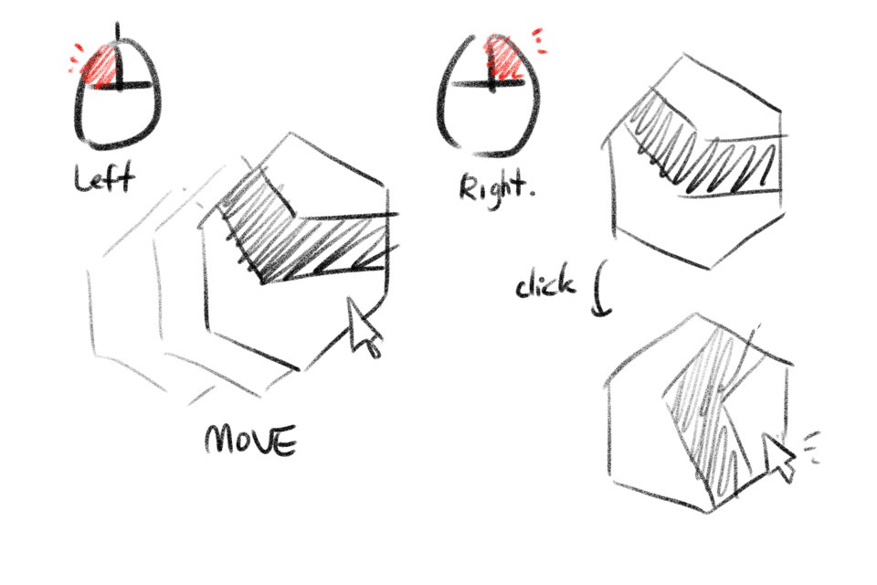

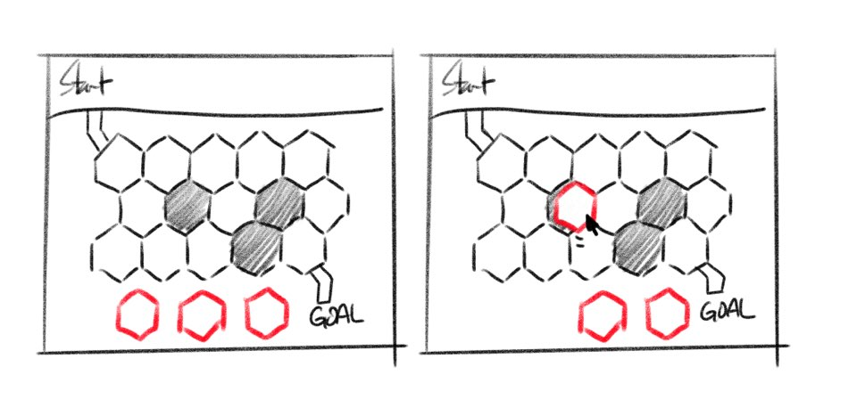

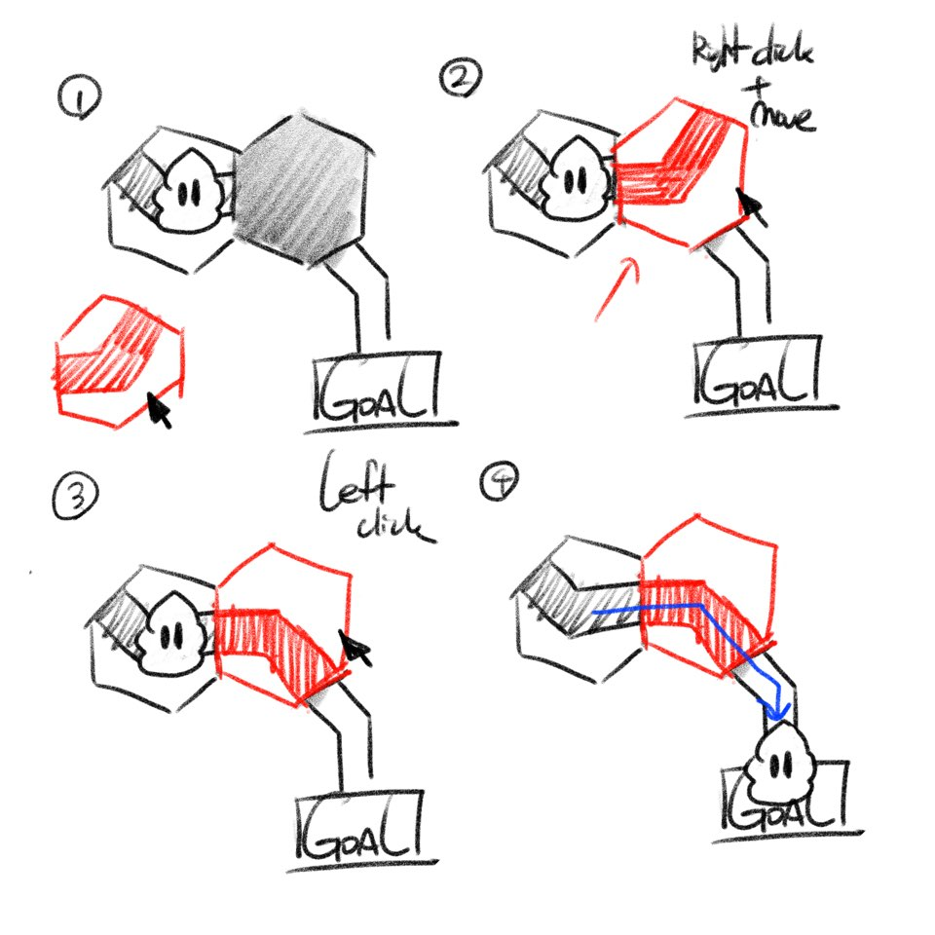

* PooPooPiPe is also a game which contains traps that the player should guess and make a strategy for the player how to avoid or use them to reach to the goal. The traps affect the players movement or direction. It could change the rotation of the puzzle piece in force, or transport the player to the other block. To clear the game, the player should also consider the location of the traps, and think to avoid them or use them to achieve the goal.

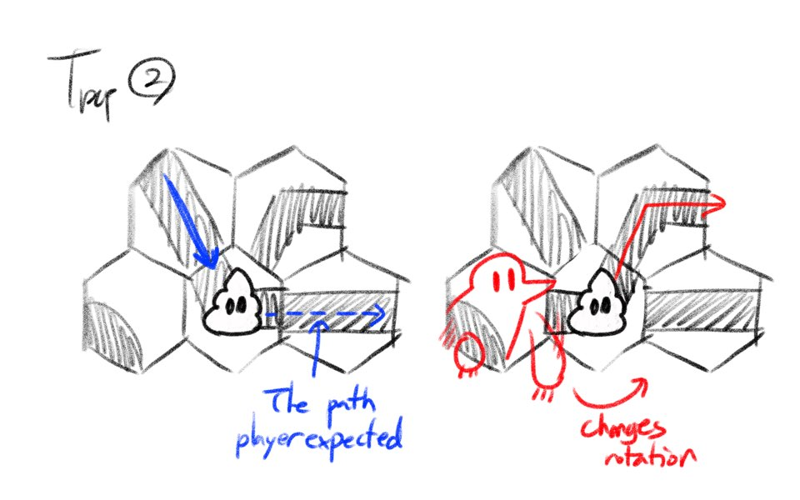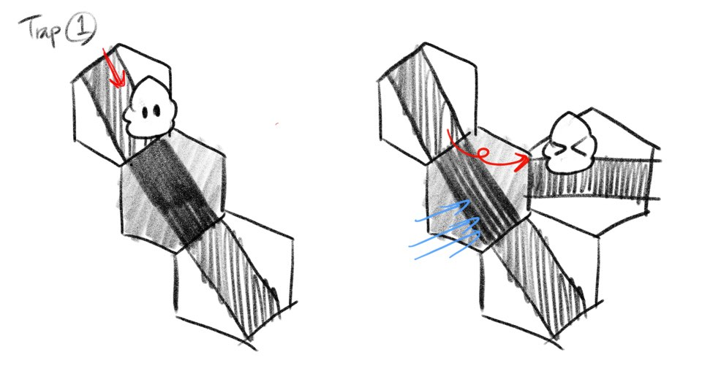

# CHARACTER OVERVIEW

Describe/show the nature of the characters the game will have.

Poo

The character which the player should help to reach the goal. It doesn’t have special powers or any abilities. The only thing it could do is to get through the connected pipes. He will be happy if it reaches to the sewage disposal tank by your help!

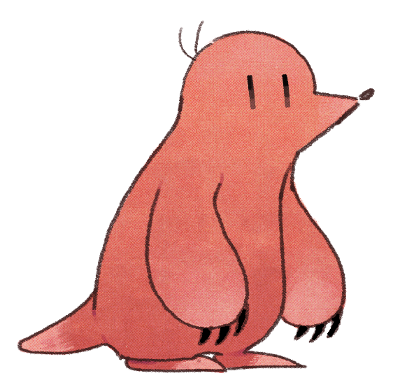Mole

Mole is a character which loves to play with friends and has mischievous character. This character rotates the pipe-line puzzle pieces which changes the rotation. The reason why is it is doing this action was just to play with the character. The player should consider his action too, which could be bothering but sometimes could be helpful.

# ART OVERVIEW

Describe/show the nature of the art the game will have.

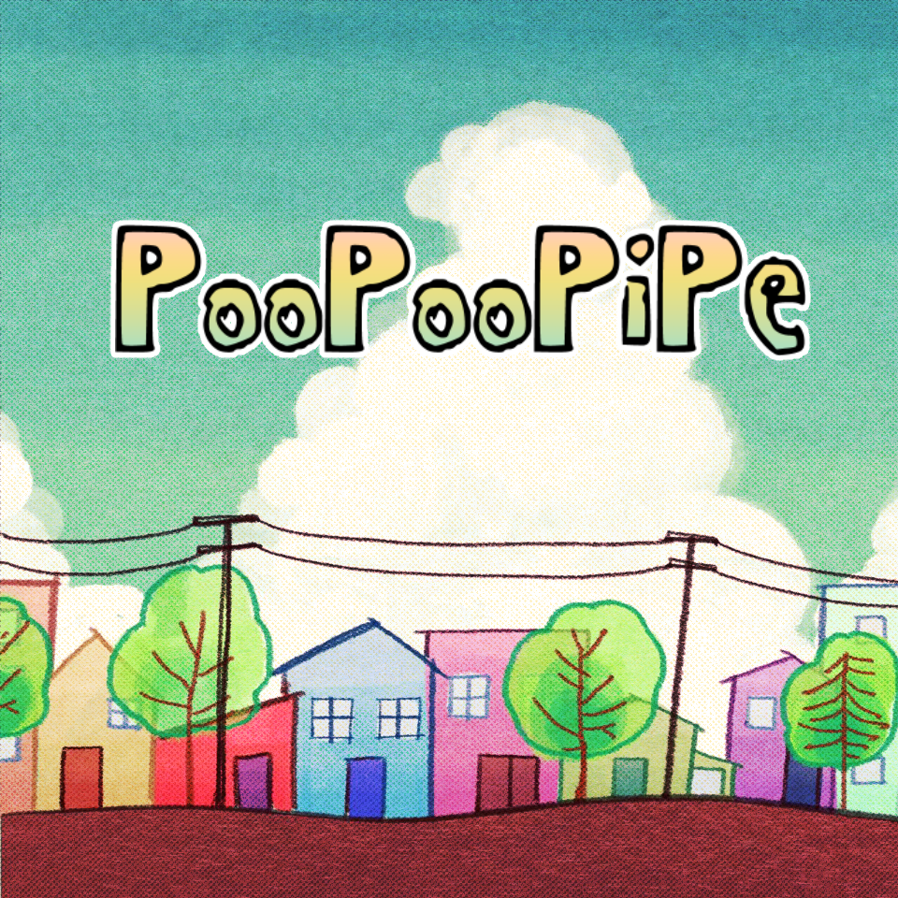

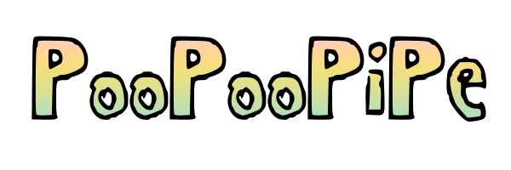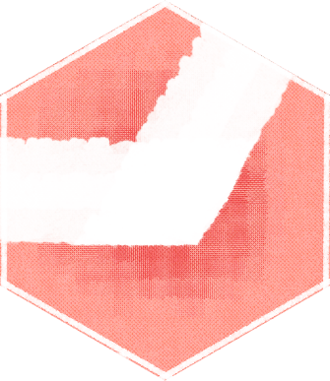

The overall aesthetics of the art style is ‘*analogue*’. The graphics are drawn by the style of hand-drawing/paintings, using the paper texture to enhance the atmosphere of analogue. Not only the background, it also uses the font which looks like it is hand-written. The overall drawings are not neat but pouting. However, this design of graphics was in purpose. Another main theme of the graphics design was ‘*childish*’, for the bright, joyful atmosphere of the game, also because of the nostalgia cause many kids did ‘poop jokes’. Therefore, we decided to reference from the children drawings. The big feature of children drawings is that they are used various colors and crooked. However, if we actually follow the exact style of children drawings, it will be looked unpolished and uncomfortable for players to watch. Therefore, we decided to follow the big style of the childish drawing, but more polished so the players could distinguish the objects and the characters of the game more clearly. In result, the art style of the game looks similar to the drawings which we could see from the children’s book, which was what we expected for the game to look like. The below drawings represents the art style that we referenced for the game.

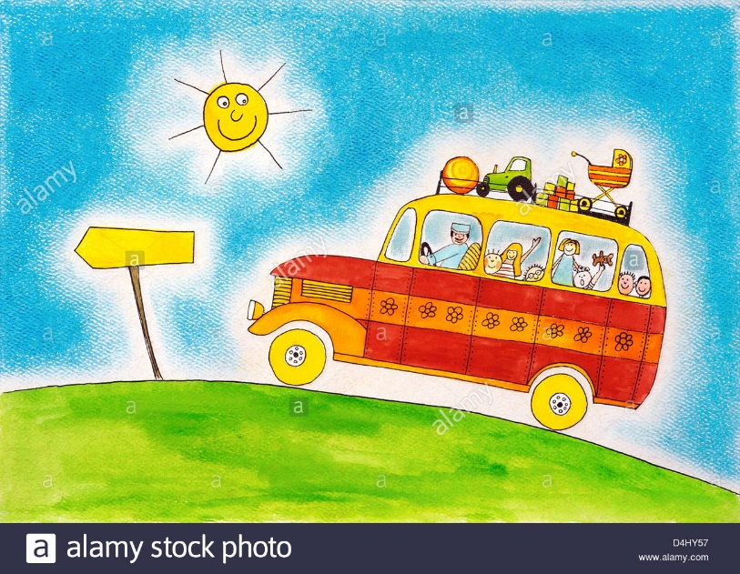

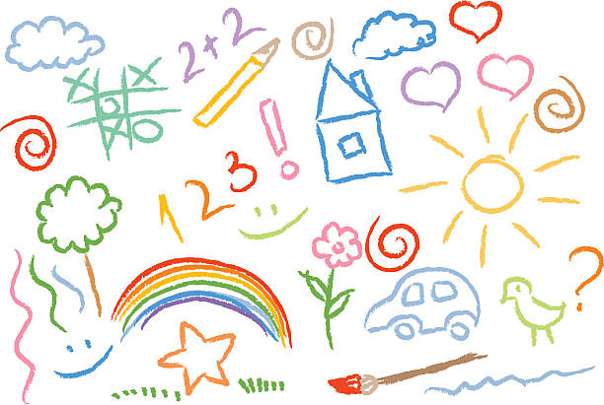

# AUDIO OVERVIEW

Describe/show the nature of the audio the game will have.

The nature of the background music of the game will be joyful and bright, overall happy. The game doesn’t have a any elements or compositions which make the game mood dark and gloomy. Story is simple, and the character is cute, therefore we are going to match the background music considering to its brightness. The good example which will represents our expectations will be the music ‘Twin Musicom – Santo Rico’, ‘Igor Khainskyi – Hawaiian Weekend’, and ‘Free Music - Happy and Joyful Children’. The second example which is given is already implemented as a main theme of the game. These music gives a feeling to a player going for a trip, enjoying their vacation, relaxing. Even though our game is a puzzle and the players should think and guess, we wanted the players to not think so complicated, but enjoy and relax.

Also, the sound effect will be simple too, as the actions what the players could do is very simple and short: move, match, and rotate. Moreover, we are not going to implement the sound which is hyper-realistic. As the game theme is goofy and childish, the sound effects will match the theme, using the exaggerated sound effects which is often used in 80~90s cartoon shows, such as Tom and Jerry. When we tried to use a sound which is realistic, it gave an uncomfortable feeling and harmed the atmosphere of the game which is bright and joyful.

# INTERFACE OVERVIEW

Show/describe the nature of the controls/HUD for the game.

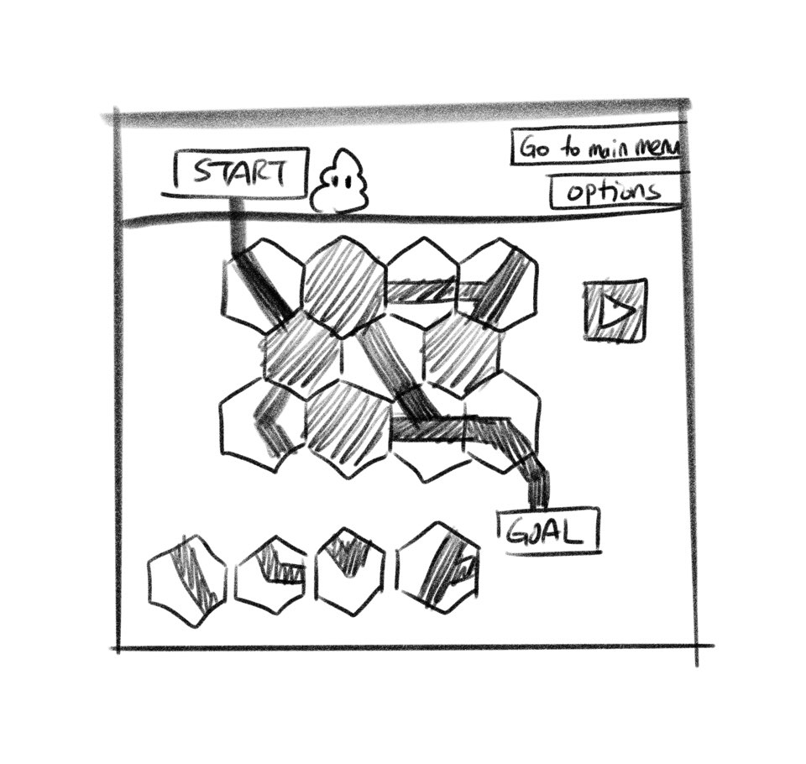

The above picture is a rough sketch of the composition interface of the game. The pieces of puzzles which is located under left, which is able for the player to move, place, and rotate them. However, as they have same design as the pipes that is already matched on the middle, we are going to distinguish them using the difference of the colors.

In addition, the game HUD will have three buttons. The first is a button to go to the main menu, second is the button which is options, where the player could modify the game (change the brightness, volume of music and sound effects, etc.). Another, there is a play button. The play button could be pressed only when the player connected the pipes to start to goal. When the player presses the button, the poo character will begin to move from start to goal, showing its movement reaching to the goal. After the poo arrives at the goal point, the player is able to keep playing by going to the next level.